One important benefit a hub brings to the home network is

protection against viruses and added security while on the Internet

shared (network-attached) storage

ability to share files among two, three, or more computers

none of the above

Hubs are manufactured with varying numbers of available ports. What are the most common port configurations available in hubs today?

2-, 4-, 6-, or 8-port

3-, 5-, 7-, or 9-port

4-, 5-, 8-, or 16-port

5-, 10-, 15-, or 20-port

For hubs and switches, the term chaining refers to

the ability to connect hubs/switches to other hubs/switches to increase the overall size of the network

the act of securing a hub or switch with cable tiedowns so that it cannot be stolen

connecting more than one computer to the same hub or switch

none of the above

1. An application used to prepare email that is private and digitally signed. _____ PGP or GPG ___________

2. A way (protocol) to download normal email or send and receive Web pages so that the content is hidden.

TLS or SSL

Question 2 – Network Utility Applications

Name a network application can be used to do the following:

a. Find the DNS name, if any, for a dotted decimal IP address: __________nslookup, host, or dig________________

b. Find the email address of the network administrator from an IP address:____ whois ________

c. Sniff packets (see the header information and data contents): ____ethereal or wireshark _____________

d. Trace the path of packets from your computer to an IP address:_____ traceroute (msdos: tracert)______________

e. Scan a network to determine IP addresses in use and TCP/UDP ports that are open: _____ nmap _______

Question 3 – Email and Web Security

a. What do you need to know before you can send a PGP secure email message to Alice? ___Alice's Public Key ____

b. What does Alice need to check the digital signature on a PGP email message? __Sender's Public Key _________

Question 4 – Intruders One or two-word answers (adjective and noun) only. "?-?" indicates the answer is a hyphenated adjective used in front of "IDS".

1. System that detects unwanted open ports across a network. nmap, nesus, …

2. Malicious code that hides in an otherwise innocent application. Trojan Horse______________

Question 5 - Base Rate Fallacy

Consider an Intrusion Detection System with a False Positive Rate of 0.00001 and a False Negative Rate of 0.1

a. If there are 1,000,000,000 legitimate transactions (connections) a day, how many false alarms will occur? ___________

1,000,000,000 x 0.00001 = 10,000

b. If there are 100 hacking attempts (connections) per day, how many true alarms will be given? ________________

100 x ( 1 - 0.1) = 90

c. How many hacking attempts will go unnoticed? ________ 10 ____________________

Question 3 – Simple Network Management Protocol

a. What is the purpose of SNMP (10 words or less)?

Provides a protocol for remote management of network equipment.

List three ways (just names) to protect a network at the network level (that do not require host-based software).

Firewall, IDS, ACL and/or NAT on Route

D: What is the Capacity (bits/sec) if the Baud Rate is 2400 per second and each symbol has 8 states (levels)?

7200 C = 24000 Baud/s * log2( 8 levels) = 2400 Baud/s * 3 bits/Baud = 7200 bits/s

1. [4 points]: Which of the following is true about Address Resolution Protocol (ARP) and learning

bridges?

(Circle ALL that apply)

A. A learning bridge maintains state that maps IP addresses to hardware (MAC) addresses.

B. A learning bridge maintains state that maps IP addresses to MAC addresses.

C. A host’s ARP table maintains state that maps IP addresses to hardware (MAC) addresses.

D. A host’s ARP table maintains state that maps hardware addresses to IP addresses.

Answer 1 The answer is: (A), (C)

3. [4 points]: Which of the following is true about DNS?

(Circle ALL that apply)

A. A query for an A record may return multiple IP addresses in the response.

B. A query for an NS record may return multiple IP addresses in the response.

C. A query for a MX record may return multiple IP addresses in the response.

D. A short TTL on an A record reply may run the risk of increasing trafﬁc at the root nameserver.

E. None of the above.

Answer 3 The answer is: (A), (C)

11. Refer to the exhibit. Which networking term describes the data interleaving process represented in the graphic?

• piping

• PDU

• streaming

• multiplexing

• encapsulation

CCNA

**2**.

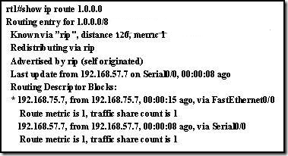

Refer to the output from the show ip route command. What can be concluded from the output of this router command?

A preferred route to the destination has not been set.

**There are two equal cost paths to network 1.0.0.0.**

Both interfaces are being used equally to route traffic.

A variance must be set to load-balance across multiple paths.

**5**. Which of the following is considered a limitation of RIP v1?

RIP v1 does not send subnet mask information in its updates.

RIP v1 is not widely supported by networking hardware vendors.

RIP v1 consumes excessive bandwidth by multicasting routing updates using a Class D address.

RIP v1 requires enhanced router processors and extra RAM to function effectively.

RIP v1 does not support load balancing across equal-cost paths.

RIP v1 authentication is complicated and time-consuming to configure.

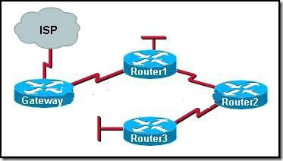

Refer to the exhibit. All routers that are shown are running the RIP routing protocol. All unknown IP traffic must be forwarded to the ISP. What router or set of routers are recommended to have both a default route and the default-information originatecommand issued to implement this forwarding policy?

only Router1

only the gateway router

all routers in the network

only the routers with LANs needing Internet access

**4**. Which IP packet field will prevent endless loops?

type-of-service

identification

flags

time-to-live

header checksum

**6**.   
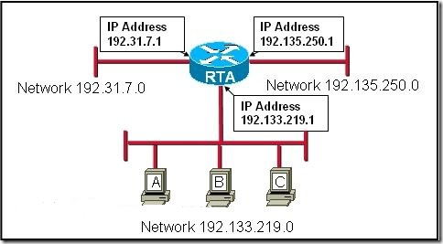   
Refer to the exhibit. Using the network in the exhibit, what would be the default gateway address for host A in the 192.133.219.0 network?

192.135.250.1

192.31.7.1

192.133.219.0

192.133.219.1

**13**. Which intermediary devices could be used to implement security between networks? (Choose two.)

router

hub

switch

firewall

access point

bridge

**15**.

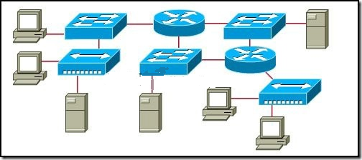   
Refer to the exhibit. All devices shown in the exhibit have factory default settings. How many broadcast domains are represented in the topology that is shown?

3

4

5

7

8

11

**17**.   
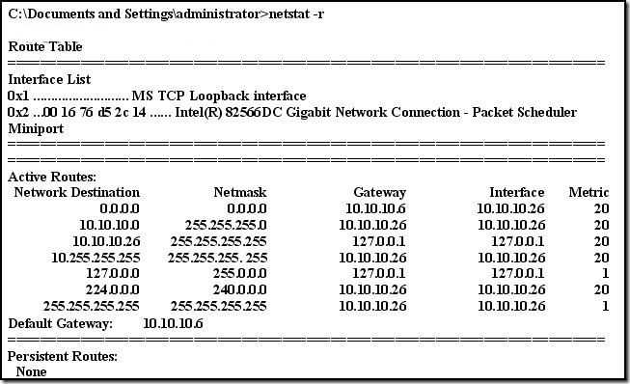  
Refer to the exhibit. A network administrator is troubleshooting a connectivity problem and needs to determine the address that is used to forward network packets out the network. Using the netstat -r command, the administrator would identify which address as the address to which all hosts send packets that are destined for an outside network?

10.10.10.26

127.0.0.1

10.10.10.6

10.10.10.1

224.0.0.0

**1**. When a network administrator applies the subnet mask 255.255.255.248 to a Class A address, for any given subnet, how many IP addresses are available to be assigned to devices?

1022

510

254

126

30

6

**4**. "CompA" is trying to locate a new computer named "CompB" on the network. Which of the following does "CompA" broadcast to find the MAC address of "CompB"?

MAC request

ARP request

ping

Telnet

proxy ARP

**11**. In a new network installation, the network administrator has decided to use a medium that is not affected by electrical noise. Which cable type will best meet this standard?

coaxial

screened twisted pair

shielded twisted pair

unshielded twisted pair

fiber optic

**29**. John has been hired as the network administrator of a local company and has decided to add more hubs to the company’s existing network. Which of the following has been caused by John’s inexperience?

collision domain extended

an increased number of collision domains

increased network performance

increased bandwidth

extended bandwidth

**32**. Which of the following protocols are used for e-mail transfer between clients and servers? (Choose three.)

TFTP

SNMP

POP3

SMTP

IMAP4

postoffice

Which transport layer protocol does DNS uses?

Which physical logical topology does LAN uses?